Computer Networks
Assignment 1

2020-21
Even Semester

Submitted By:
Abhishek Kumar
19ucs241
Lab Batch: C4
Task1: Physical and Data Link Layer

1) Find out the network cards in your machine. What is the speed?

00:03.0 Ethernet controller: Intel Corporation 82540EM Gigabit Ethernet Controller (rev 02)

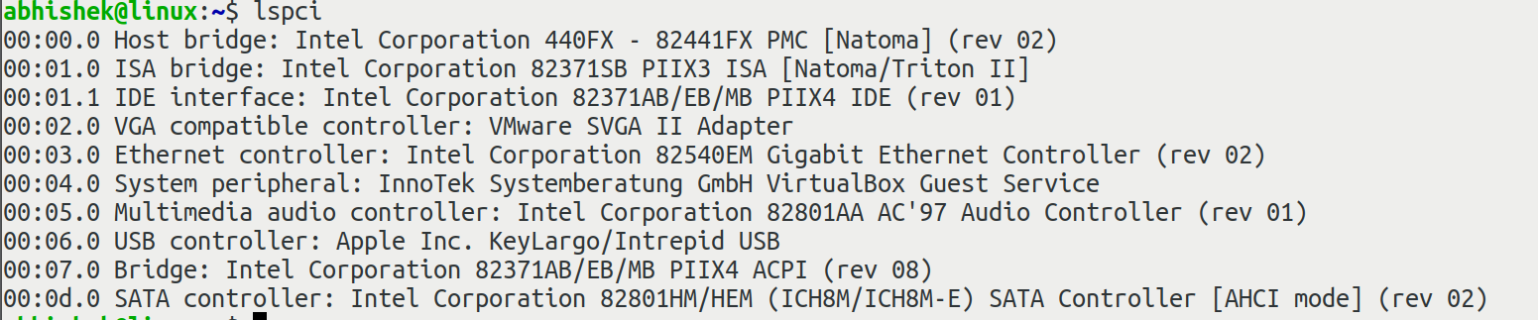

Speed: 1Gbit/s

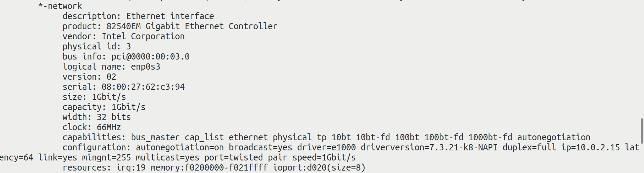

2) What is the current speed of the network interface? What offload features are enabled?

Current Speed: 1000Mb/s

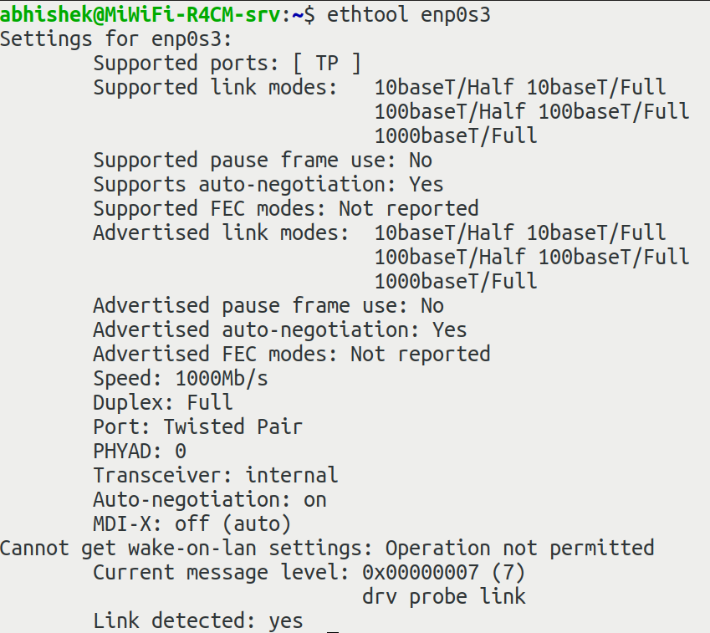

Enabled offload features:

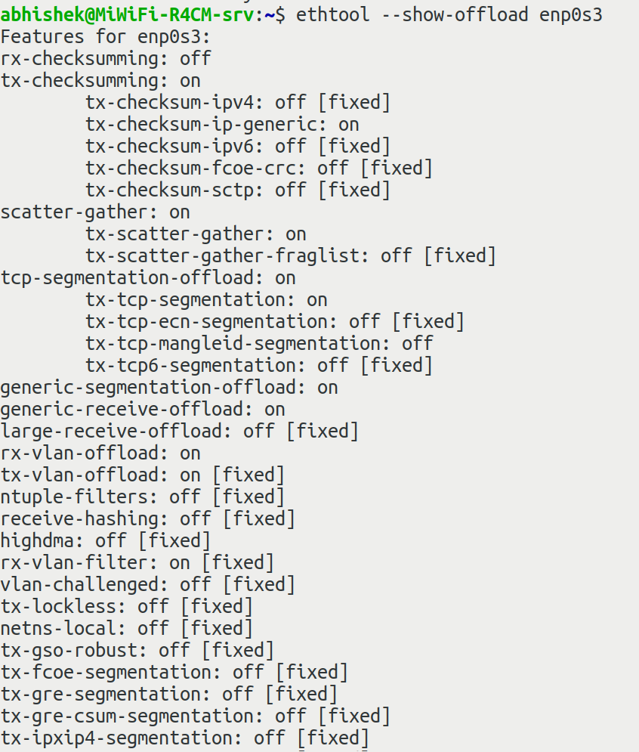
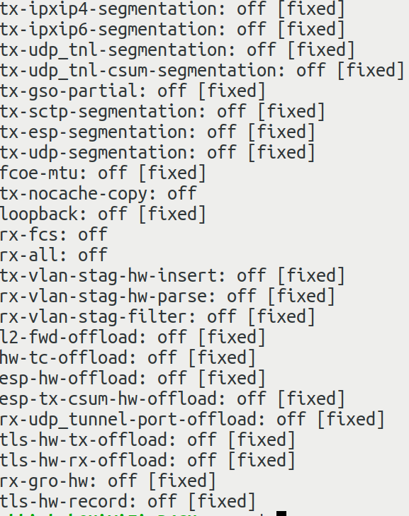

3) What is the MAC address of your machine?

MAC Address of enp0s3: 08:00:27:62:c3:94

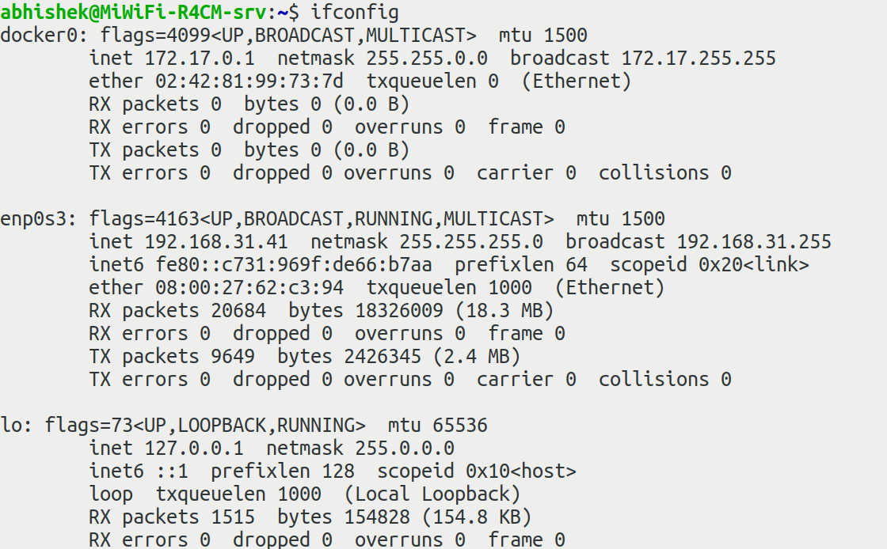

4) How many bytes did your eth0/eth1 interface receive since booted?

enp0s3 recieved 18326009 bytes i.e. 18.3 MB.

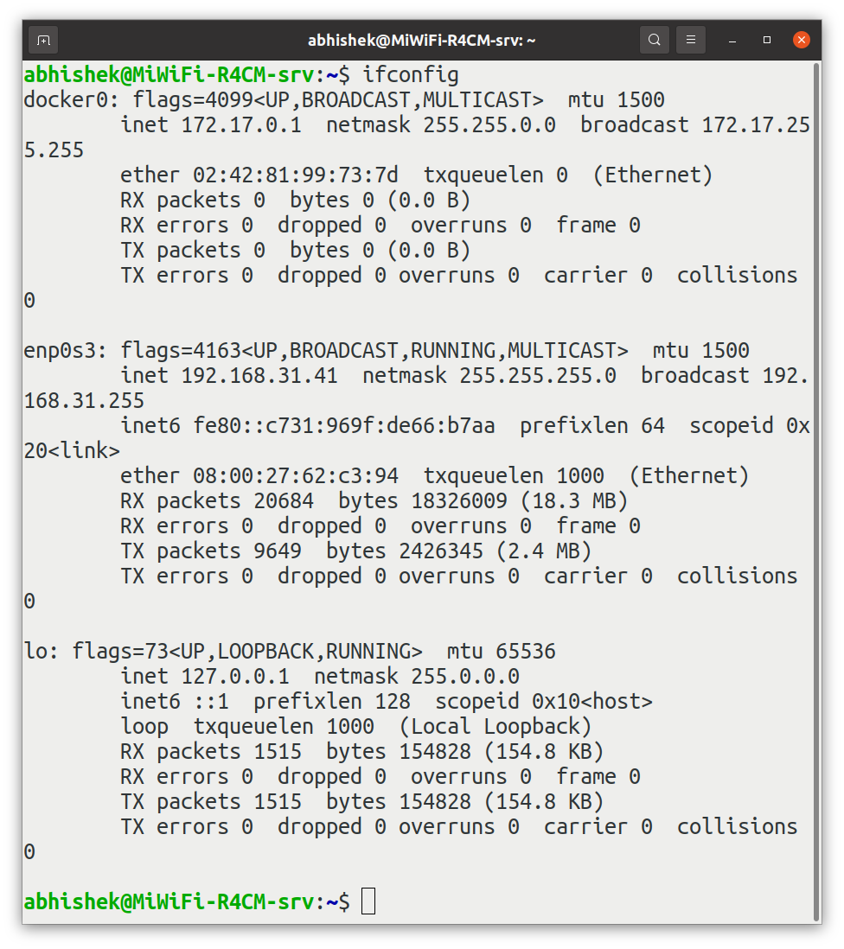
5) What is the MTU setting for eth0/eth1?

MTU: 1500 bytes

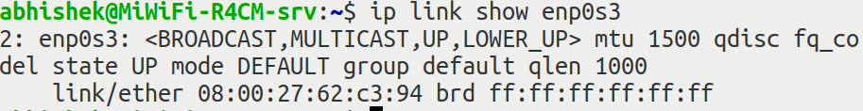

Task 2: Network Layer

1) What is the network address of your machine? What is the default gateway (IP address and MAC address)of your network?

Network Address of machine: 192.168.31.41

Default Gateway :
IP Address: 192.168.31.1
MAC address: 8c:53:c3:5b:e0:8c

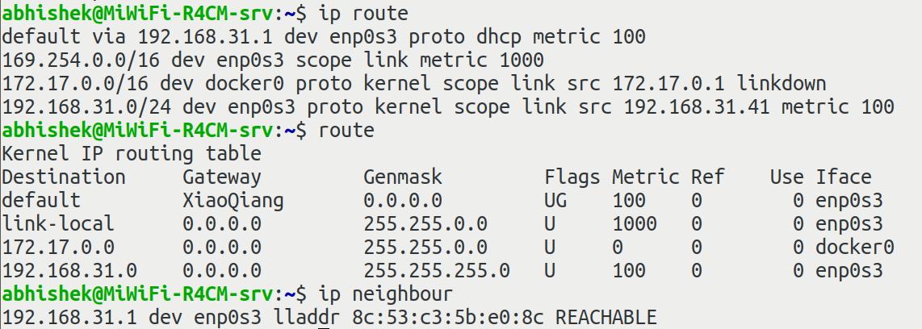

2) Show the ARP entries in your machine.

Shown below:

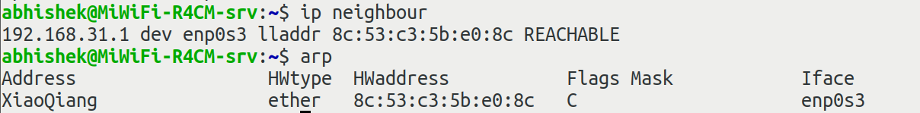

3) Perform a traceroute/mtr to any web address. Provide the full traceroute/mtr output.

Command: mtr www.whatismyip.com
Output:
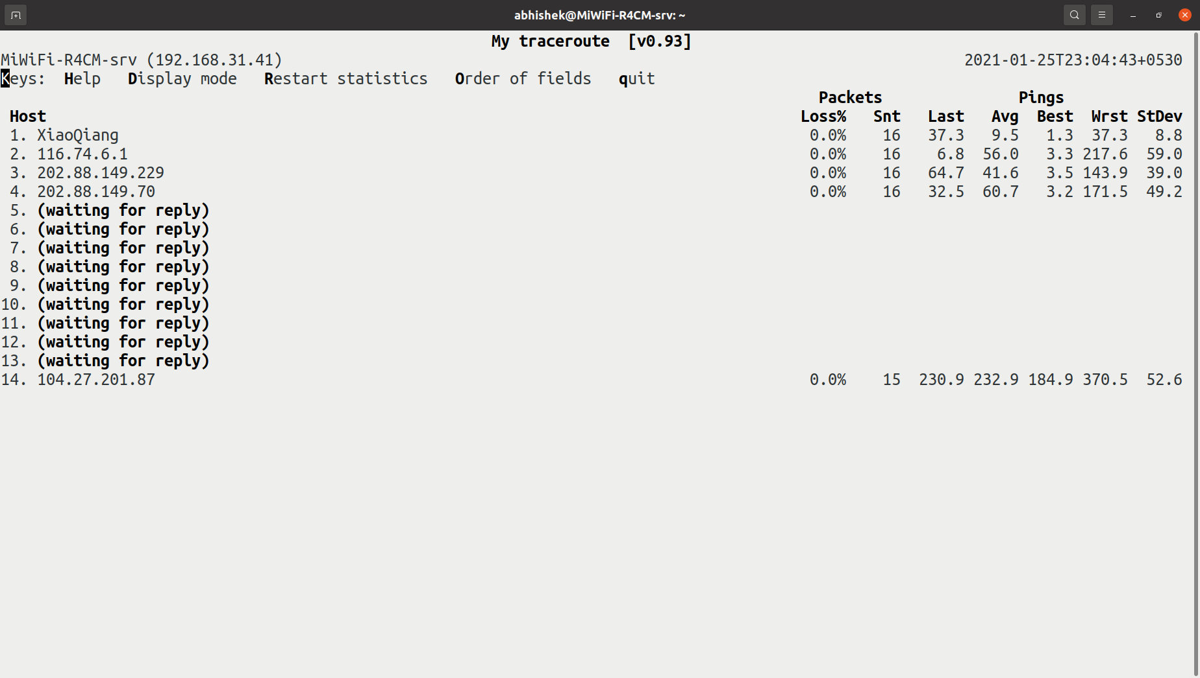

Command: sudo traceroute google.com -I
Output:
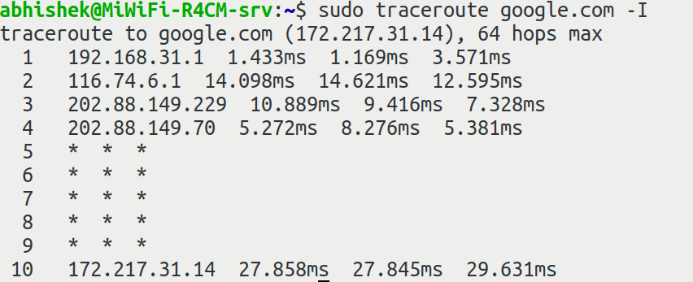

4) How many IP packets are received by your machine after current boot process?

Number of packets recieved by enp0s3 : 46092

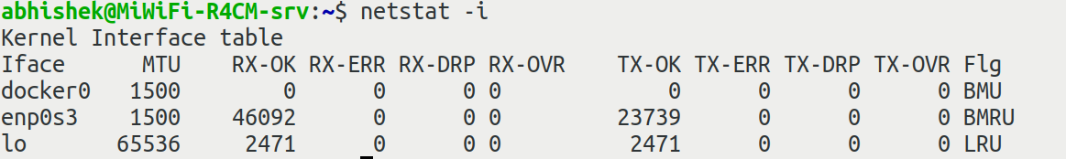

Task 3: Transport Layer

1) Find the active TCP connection on your machine?

Shown below:

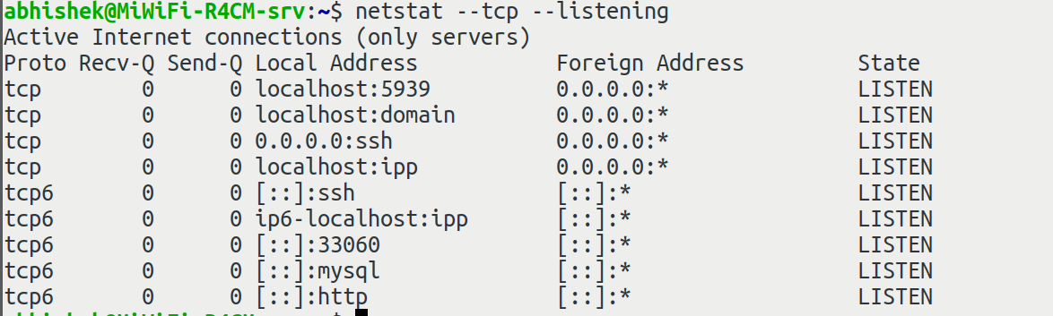

2) How many sockets are currently opened on your machine?

Shown below:

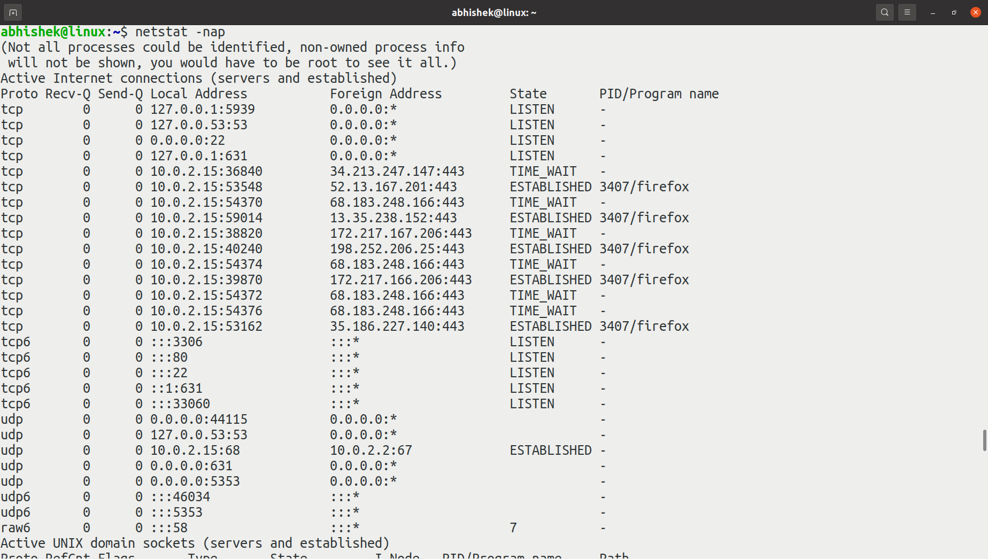
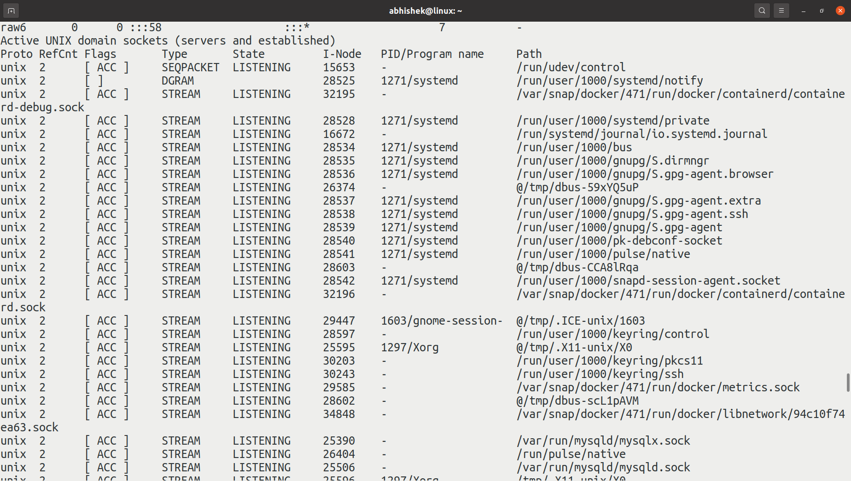

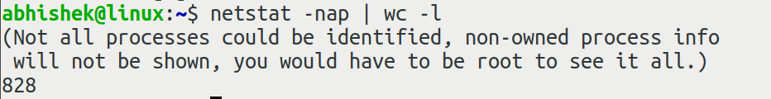

3) How many applications are accessing network services on your machine? Also, identify their access protocol.

There are 27 entries, i.e. 27 applications are accessing network services and access protocol is either TCP or UDP as shown:
